**Digital Wireless Communication Practical Laboratory Session**

Wireless Communications 371-1-1903

Spring 2020

# Part 1 – Multipath

## **Description**

Multipath results from that fact that in most communication environments, we don't have a single path for the signal to travel from the transmitter to the receiver. Any time there is an object that is reflective to the signal, a new path can be established between the two nodes. Surfaces like buildings, signs, trees, people, cats, etc. can all produce signal reflections. Each of these reflective paths will show up at the receiver at different times based on the length of the path. Summing these together at the receiver causes distortions, both constructively and destructively.

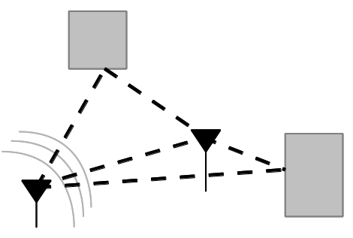

In this experiment we will construct a communication system using the GNU Radio freeware. During the sending of data we will change the channel model to include more and more reflections to create a multipath environment.

## **Equipment needed**

* 2 Linux PC with GNU Radio installed.
* 2 LimeSDR/USRP Software defined radios.
* 1 SMA to SMA RF cables
* 2 ULF-SMA Adapters.

If any of the above equipment is missing or defective, notify the lab instructor prior to starting this session or otherwise you may obtain false results (and major frustration).

## **Equipment Setup**

## **Recording**

This is a practical session; thus, you most likely do not have this equipment at your disposal at home other than currently, here. Therefor it is highly recommended that you document and record your results during this session. This will assist you in completing you report at home. You may not fully complete what that is required of you during the time you have, take this into account.

## **Instructions**

1. Open

## **Report**

# Part 2 – Fading